

User Guide

December 2019



Real Life

Life Changing

Changing Healthcare

Copyright

NAVVIS Coreo View user's guide release 1.00.

Copyright © 2019 NAVVIS & Company, LLC. All rights reserved.

Trademarks

The other product names mentioned may be trademarks of their respective owners.

Disclaimer

Sample names and persons used in this document are purely fictitious and do not refer to real names or persons.

This user's guide has been created with utmost care; nevertheless, it is not guaranteed that this document is error free.

No part of this document may be reproduced or transmitted in any form or by any means, electronic or mechanical, for any purpose, without the express written approval of Navvis & Company.

Table of Contents

Preface 6

Exhibit A: Coreo View User Function 8

1 User On boarding 9

1.1 Log into Coreo View - First time user 9

1.2 Manage locked NAVVIS – okta SSO account 13

1.3 Reset a forgotten or expired password 13

2 Screen layout and navigation 15

2.1 Left Pane 15

2.2 Header Tool Bar 17

3 The Three View Layouts 19

3.1 Bed View Layout 19

3.1.1 Bed View Layout Elements 19

3.2 Prioritized View Layout 24

3.2.1 Screen Layout for Most Inpatient Admissions 24

3.2.2 Screen Layout for Most Emergency Visits 26

3.2.3 Screen Layout for Highest Risk Scores 26

3.2.4 Screen Layout for Most Recently Admitted – Inpatient 27

3.2.5 Screen Layout for Most Recently Discharged – Inpatient 28

3.2.6 Screen Layout for Longest Length of Stay 28

3.3 Geo-Map View Layout 29

4 Using Filters and Themes 31

4.1 Filters 31

4.2 Themes 35

4.2.1 Apply a theme 35

4.2.2 Set a theme as the home default theme 35

4.2.3 Edit a theme 36

4.3 Normal view and Stacked view 37

4.4 All, Available and Patient Viewing Modes 38

5 Bed view features 40

5.1 Create bed 40

5.2 Assign patient 40

5.3 Move patients based on ADT events 40

5.3.1 Request move 40

5.3.2 Quick move 40

5.3.3 Move within a location 40

5.3.4 Moving across locations 40

6 Prioritized view features 40

6.1 Card view 40

6.2 Sorting 40

6.3 Application of the date filters 40

6.4 Filters and themes 40

7 Geo-mapping view features 40

7.1 Geo-map view 40

7.2 Toggle views 40

7.3 Search functionality 40

7.4 Geo-map view plotting 40

7.5 Display settings 40

7.6 Drill down view 41

7.7 Pop up views 41

7.7.1 Acute Care 41

7.7.2 Post-Acute Care 41

7.7.3 Community resources 41

8 Switching navigation between views 41

8.1 Toggle views 41

9 Patient summary 41

9.1 Layout and description of different tabs 41

9.2 View patient summary 41

9.3 Patient summary based on bed information 41

9.4 Patient summary based on length of stay (LOS) 41

9.5 Patient summary based on patient information 41

9.6 Length of stay (LOS) 41

9.7 Activities & attributes 41

9.8 Patient disposition 41

9.9 Bed attributes 41

9.10 Coreo face sheet 41

10 Search feature 41

10.1 Global search 42

10.1.1 Coreo summary 42

10.1.2 Flagged summary 42

10.1.3 Bed summary 42

10.1.4 Displayed search (Bed view search?) 42

11 Flagging patient records 42

11.1 Flag a patient record 42

11.1.1 Patient summary (Give reference to topic 8 above) 42

11.1.2 Global search 42

11.1.3 Prioritized view 42

11.1.4 Geo-map view 42

11.1.5 Bed view 42

11.2 Applying Filters and saving theme for flagged patients 42

11.3 Flagged Summary Pop Up Elaboration 42

12 General reports 42

Exhibit B: Coreo View Administrative Function 43

1 Coreo View Administrator Tasks 44

1.1 Navvis account activation for the Coreo View administrator user 44

1.2 Manage locked Navvis administrator account 48

1.3 Reset a forgotten or expired administrator password 48

2 Settings to manage Coreo View regular users 50

2.1 Settings page layout 50

2.2 Create groups 50

2.3 Manage user access 52

2.4 Set up locations 53

2.5 Manage patient cohorts 53

2.6 Manage user rosters 53

2.7 Create user roles 53

2.8 Create users 55

3 Automation Events 56

3.1 Discharging ED patients automatically and moving to CC after a configurable time 56

3.2 Moving the low risk patient automatically from ADT to cc after a configurable time 56

3.3 SIGNAL R –keeping the screen updated automatically 56

4 Administrative Reports 56

4.1 Automation reports 56

4.2 Automation action 56

5 Appendices 57

6 Glossary 58

7 Index 59

Preface

Welcome to the release of the NAVVIS Coreo View user guide.

About Navvis Coreo View

NAVVIS Coreo View is a software platform which empowers the users to manage the status and the flow of patients through Acute Care (AC), Post-Acute Care (PAC) and home networks.

Coreo View is HIPAA (Health Insurance Portability and Accountability Act) compliant and is available as a SaaS (Software-as-a-Service) cloud solution enabling management of patients with real-time data. Coreo View is part of the Coreo ecosystem which allows cross-continuum care coordination and ensures seamless care transition.

Navvis & Company provides counsel to health systems, hospitals and physician groups on the development of innovative, market-linked strategies to build future-ready health systems, cultivate tomorrow’s leaders and strengthen strategic performance.

Purpose of this document

This guide is the primary source of information about Navvis Coreo View. It contains overviews, processes, and procedure to use the Coreo View application effectively.

Intended audience

1. Coreo View administrator users who are assigned the task of managing the regular users of the Coreo View application
2. The regular users of the application who include the following personnel:

* Clinical staff and hospital administrators
* Employees, consultants, contractors or agents of the clinicians or patients who have been invited by the clinician or patient to access and use the service to participate in the care of the patient.
* Any other person or entity involved in the care of the patient including patient's care providers, patient's insurer or payer, or a social worker, or government agencies.

Organization of the document

This document contains the following modules:

* Exhibit A: Coreo View User Function
  + Module 1, “User on boarding”
  + Module 2, “Screen layout and navigation”
  + Module 3, “Filters and Themes”
  + Module 4, “Bed view features”
  + Module 5, “Prioritized view features”
  + Module 6, “Goo-map view features”
  + Module 7, “Switching the navigation between views”
  + Module 8, “Patient summary”
  + Module 9, “Search feature”
  + Module 10, “Flagging patient records”
  + Module 11, “General reports”
* Exhibit B: Coreo View Administrative Function
  + Module 1, “Coreo View Administrator Tasks”
  + Module 2, “Settings to manage Coreo View regular users”
  + Module 3, “Automation events”
  + Module 4, “Administrative reports”

Conventions

This document uses the following conventions:

| Convention | Item |
| --- | --- |
| **boldface** font | **Menu** items, **Tab** names, **Text** **box** names, **List** **box** names, **Button** names and **Navigation** paths |
| Text in blue | Hyperlinks |
|  | Note: Notes contain helpful suggestions. A note will inform the reader about any deviation in the sequence of instructions or helps the reader save time in understanding why something is not working. |
|  | Tip: The information will help the user solve a problem faster, or to perform an action in a different way. |
|  | Caution alerts the reader to avoid doing something that could result in loss of data or any other damage. |

Browsers Versions for Coreo View

The Coreo View application is available on desktops, laptops, IOS devices and android tablets.

| Browser | Version |
| --- | --- |
| Google Chrome | 74 |
| MS Internet Explorer | 11 |
| Macbook - Safari | 12.1.1 |
| Samsung Tab – Google Chrome | 7.0.0 |
| IPad IOS - Safari | 12.1 |

Coreo View User Function



# User Onboarding

A first-time user of Coreo View receives an automated email verification link from the okta system administrator to activate the okta account. okta single sign-on(SSO) provides a single secure home page to use the Coreo View application.

## Log into Coreo View - First time user

Follow these steps to activate the okta SSO account to access Coreo View:

1. Open the email link sent to your email inbox by the okta administrator.



1. Email Notification
2. Select the ActivateAccLinkGreenBox.png link. The **Create your Navvis account** screen opens.

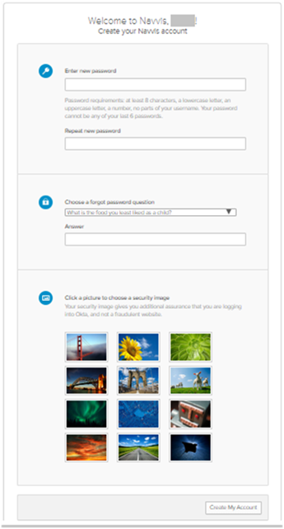

1. Create Your Navvis Account Screen
2. Enter the new password in **Enter new password**. The password must be at least 8 characters long and a maximum of 25 characters.

The password must be a combination of these following characters:

| Description | Characters |
| --- | --- |
| Upper case characters | A – Z |
| Lower case characters | a – z |
| Digits | 0 – 9 |
| Special characters | ~ ! @ # $ % ^ & * _ - + = ` | \ () {} [] : ; " ' < > , . ? / |

1. System Accepted Password Characters
2. Reenter the password in the **Repeat new password** box.
3. The user must add a security question to reset a new password in the scenario where user may forget the password during the future use.
4. Under **Choose a forgot password** question, select the arrow to view the questions.



1. Choose A Forgot Password Question
2. Choose a security question from the list.
3. In the **Answer** box, enter the answer. You must remember this answer because it is used at a later date to reset a forgotten or expired password.
4. Choose a picture as a security image in the **Create your Navvis account** screen and then select **Create My Account**.

|  |  |
| --- | --- |
|  | The security image displays in the NAVVIS Sign In screen on entering the user name. |

1. The **Navvis** landing screen opens.

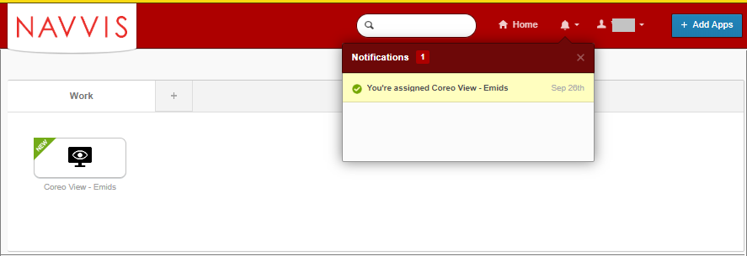

1. NAVVIS Landing Screen
2. Select the **Coreo View - Emids** button on the landing screen.
3. The **NAVVIS Sign in** screen opens.

|  |  |
| --- | --- |
|  | Once the user accepts EULA and the Navvis – okta SSO account is activated, the new user becomes an existing user.  As an existing user, go to www.navvis.oktapreview.com to open the NAVVIS Sign in screen. |



1. NAVVIS Sign In Screen
2. Enter the user ID in the **Username** box on the.
3. Enter the password in the **Password** box. The password must be at least 8 characters long and a maximum of 25 characters.
4. Select **Sign In**.
5. The EULA screen displays for a first-time user of Coreo View. A first-time user of Coreo View is required to accept the EULA (End User License and Business Associate Agreement) before accessing the Coreo View application.

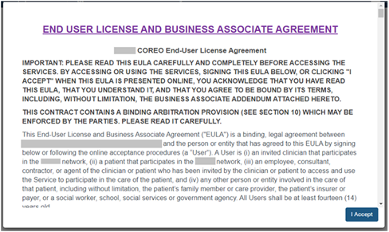

1. EULA PAGE
2. Read the terms and conditions and select the **I Accept** button. Your NAVVIS account is activated successfully and the NAVVIS Coreo View home page opens.

## Manage locked NAVVIS – okta SSO account

The Navvis – okta SSO account locks for the following reasons:

* The user exceeds five failed login attempts within 24 hours. The login attempts fail when the user enters an incorrect password.

The locked account resets after 24 hours and the user can log in to the account after 24 hours without contacting the okta system administrator.

|  |  |
| --- | --- |
|  | To unlock the NAVVIS account immediately after the five failed login attempts, contact the okta system administrator. |

* The okta system administrator can lock the NAVVIS – okta SSO account as per the company lock account policy.

## Reset a forgotten or expired password

The okta Single Sign-On password policy specifies that the password expires after 60 days, and the user must reset the password periodically.

Also, if the user forgets the password, Navvis – okta gives the option to reset the password.

Follow these steps to reset the password:

1. Go to www.navvis.oktapreview.com to open the **Navvis Sign in** screen.



1. NAVVIS Sign In Screen - Forgot password? Option
2. Select the **Need help signing in?** drop-down list.
3. Select the **Forgot password?** option to open the **Reset Password** screen.



1. Reset Password Screen
2. Enter the e-mail or the user name in the **Email or Username** box.
3. Select **Reset via E-mail**. The user can reset the password using the verification link sent to the user’s email address.
4. Reset the password with the following considerations:

* The new password cannot be among the previous six passwords.
* The password expires after 60 days and the user must reset the password periodically.
* The user will be locked out of the application after five failed login attempts. The login attempts fail when the user enters an incorrect password. Contact the okta administrator to reset the password.

On the successful resetting of the password, the new password is reset for the Navvis okta Single Sign-On account.

# Screen layout and navigation

Each screen in Coreo View has the same structure; however, few user interface elements differ depending on the user’s role and permissions.

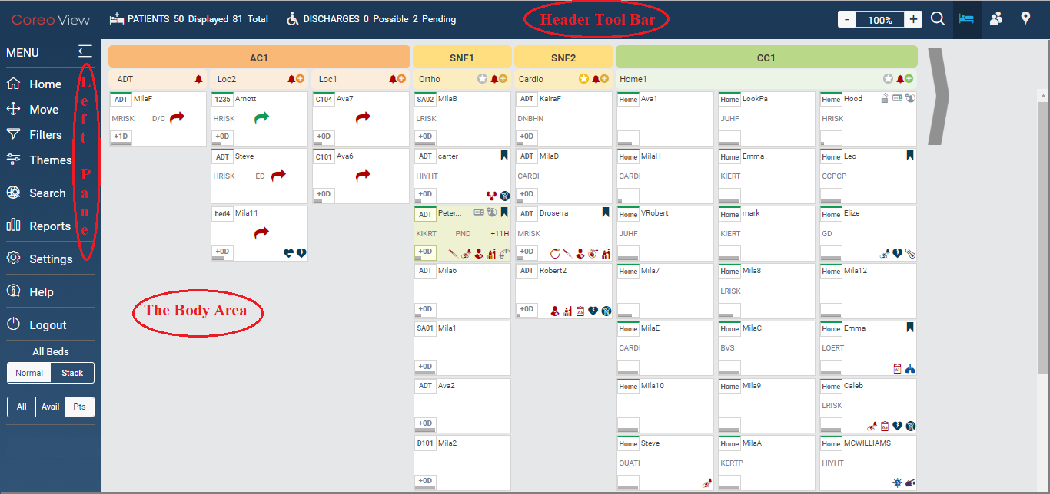

1. Coreo View Home Page

The Coreo View home page layout includes the following areas:

* Left pane: The left pane has a list of menu items and buttons to perform bed management functions for the Coreo View patients and to navigate the application.
* Header tool bar: The header tool bar includes buttons to switch between the three main views of Coreo View and the patient census for the screen layout.
* The body area: The display in the body area is based on the three main views of Coreo View, the **Bed View**, the **Prioritized View** and the **Geo-Mapping View**.

Left Pane

Refer to the following table to view details about the menu items and buttons included in the left pane.

| Icon | Element name | Description |
| --- | --- | --- |
|  | **Home** menu | Opens the home screen, the first screen of the Coreo View application |
|  | **Move** menu | Use **Move** to process the patient move requests. |
|  | **Filters** menu | Use **Filters** to display patient information based on the pre-defined filter criteria. |
|  | **Themes** menu | Use **Themes** to create and save new themes based on the filter criteria. |
|  | **Search** menu | Use **Search** to do a global search of patients from the Coreo Analytics application. |
|  | **Reports** menu | Use **Reports** to generate facility reports, audit log reports and automation log reports. |
|  | **Settings** menu | Use **Settings** to manage groups, locations, patient cohorts, user access and permissions. |
|  | **Help** menu | Use **Help** to access the Coreo View user help document. |
|  | **Logout** menu | Use this to logout of the Coreo View application. |
|  | **All Beds** group | This button group has two buttons, **Normal** and **Stack.** |
|  | **Normal** view button | Normal view is the default view. It displays the empty bed cells and the occupied bed cells in each column placed adjacent to each other.  The beds per column are categorized based on the three groups and their locations. |
|  | **Stack** view button | Displays the empty bed cells and the occupied bed cells in each column placed one below the other.  The beds per column are categorized based on the three groups and their locations. |
|  | Tristatebutton | This button group has three buttons, **All, Avail** and **Pts.** |
|  | **All** button | Select **All** to view the empty bed cells, the bed cells occupied with patients and the empty locations. |
|  | **Avail** button | Select **Avail** to view the empty bed cells that are available to assign to the patients and the occupied beds. |
|  | **Pts** button | Select **Pts** to view all the bed cells that are occupied with patients. This is the default view in the tristate. |

1. Left Pane Elements

## Header Tool Bar

Refer to the following table for details about the header tool bar elements:

| Icon | Element name | Description |
| --- | --- | --- |
|  | Coreo View logo | The Coreo View logo |
|  | PATIENTS | Patient count |
|  | Displayed | The number of patients across all the three groups, Acute Care (AC), Post-Acute Care (PAC), and Cross Continuum (CC) displayed on a single screen of the bed view.  This count is dependent on the type of view selected through the Tristate button.  When the user navigates to the next screen using the chevron icon, this count increases and adds to the previous patient count. |
|  | Total | The total number of patient across all the three groups spanning all the screen layouts. |
|  | DISCHARGES | Patient discharges |
|  | Possible | The number of patients for possible discharge where the doctor’s approval is awaited. |
|  | Pending | The number of patients pending for discharge where the discharge order is approved. |
|  | Magnification icon | Zoom in (+) to increase or zoom out (-) to decrease the bed view layout magnification. 60% being the least and 240% being the maximum magnification values. |
|  | Coreo View Search icon | Search the patient records in bed view based on criteria such as patient name, MPI (Master Patient Index), group, location, cohort details. |
|  | Bed view | Displays patient and bed information organized by groups and locations with bed cells arranged vertically below. |
|  | Prioritized view | Displays a simplified view of the patient list that is sorted by pre-defined criteria and applied to a user specified time range. |
|  | Geo-map view | Displays graphical markers representing the number of patients associated with the location on a geographical map.  The view can be filtered based on the three groups, AC, PAC, and CC, and may include pharmacies and food pantries. |

1. Header Tool Bar Elements

# The Three View Layouts

The Coreo View users can view the patient data with respect to groups and locations by selecting between the following three layouts:

* The bed view
* The prioritized view
* The geo-map view

## Bed View Layout

The bed view layout displays the patient information based on the type of group, location, patient cohorts, patient attributes, bed attributes, bed activities, and patient move requests. The bed view is the home default layout.

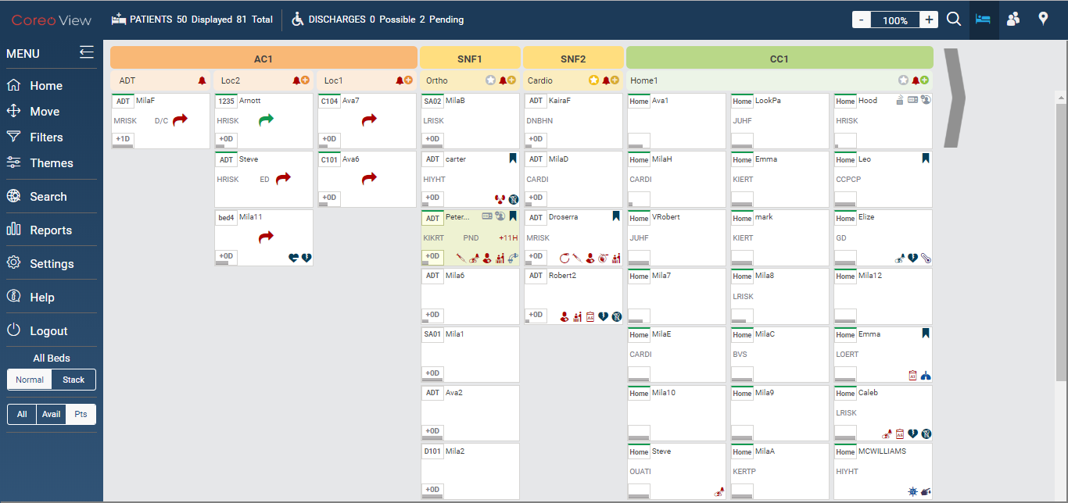

1. The Bed Layout View

Bed View Layout Elements

Refer to the following table for details about the bed view layout elements:

| Icon | Element name | Description |
| --- | --- | --- |
|  | Group header bar | The header bar displaying the group color code and the group name |
|  | AC group bar | The color code for Acute Care (AC) group |
|  | PAC group bar | The color code for Post-Acute Care group |
|  | CC group | Color code for Cross Continuum group |
|  | Location header bar | The header bar displaying the location attached to the group |
|  | Location name | The location belonging to the group |
|  | Avail beds | Displays the available empty beds and the total number of beds for that location. |
|  | Star icon | Represents the NAVVIS’s partnership agreement levels with the groups.  **Platinum**, **Gold** and **Participating** are the three tier levels. |
|  | Bell icon | A red bell icon Indicates overdue patient activities, patient move request, pending patient discharges and bed cleaning tasks; And that the patient needs to be attended without any further delay. |
|  | A black bell icon indicates that the patient’s discharge process is complete. |
|  | Add bed icon | Use this to add a new bed.  A new bed is either a standard bed or an overflow bed type indicating that a patient is waiting for a bed, for example as in a hallway. |
|  | Bed cells | A bed cell displays the pictorial summary of a bed, any assigned patient and all the related information. The summary is displayed as component icons.  An empty bed cell which is available for patient is yellow and an occupied bed cell is white.  The bed highlighting color depends on the patient disposition status. |
| Bed cell component icons | Icon name | Description |
|  | Bed id | The bed identification number |
|  | Patient name | The first name of the patient |
|  | Bed attributes | The bed attributes include **Male** **Room**, **Female** **Room**, **Bariatric**, **Mobile** **Home**, **Private** **Room** and so on. Refer to the Bed Attributes figure to view the complete list of bed attributes. |
|  | Flag icon | A patient record is flagged when the patient in Coreo Analytics is not assigned to the bed view and yet needs to be monitored.  Coreo Analytics stores the master list of all the patients.  A blue flag icon represents that the patient is in the flagged status. |
|  | A grey flag represents that the patient is not in the flagged status. |
|  | Alert time | Alert time in hours displays if the patient disposition is not processed within the set time frame. |
|  | Move request arrow. | The light green arrow indicates that the patient’s move request from one bed to another bed is initiated and an approval is pending |
|  | The dark green arrow indicates that the patient’s move request from one bed to another bed is accepted. |
|  | The red arrow indicates that the move request has been rejected. |
|  | Patient disposition status | Displays the patient disposition status. |
|  | Patient cohort | The cohort the patient is assigned to.  The patients are categorized into cohorts based on their ailments and the risk factor associated with it. |
|  | LOS indicator | The patient’s length of stay in the facility, counted in number of days. |
|  | Patient attributes icon and Patient activities icon | The patient attributes include **Chest Pain**, **Fall** **Risk**, **Diabetes** and so on. The patient activities include **Insulin** **Drip**, **Med** **reminders** and so on. Refer to the Patient Attributes and Patient Activities figure to view the complete list of patient attributes and activities. |
|  | Chevron icon | Use this to navigate from one bed view screen to another. |

1. Bed View Layout Elements

Refer to the following table for information on the patient disposition status and bed highlighting colors:

| Patient Disposition Status | Bed Cell Highlighting Color | Acronym Displayed in the Bed Cell |
| --- | --- | --- |
| Emergency | White | ED |
| Observation | White | OBS |
| Admitted | White | No Acronym displayed |
| Discharge Possible | Aqua blue | POS |
| Discharge Pending | Green | PND |
| Complete | White | D/C |

1. Bed Highlighting and Patient Disposition Status

## Prioritized View Layout

Use the **Prioritized view** feature to display the patient details and bed information of the AC group for a specified time range and based on the following criteria:

* **Most Inpatient Admissions**
* **Most Emergency Visits**
* **Highest Risk Scores**
* **Most Recently Admitted - Inpatient**
* **Longest Length of Stay**

The screen layout for each of the prioritized layout view is almost the same except for few items which is detailed in the following sections.

Screen Layout for Most Inpatient Admissions

Refer to the figure for the prioritized view layout with most patient admissions:

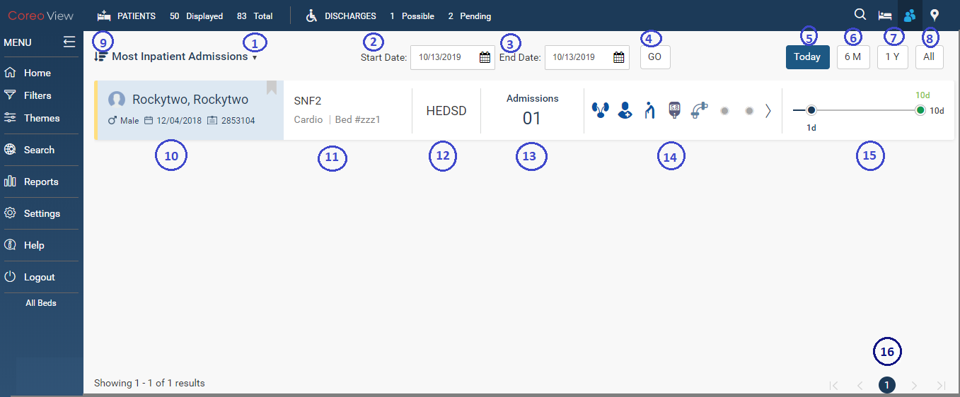

1. Prioritized View – Most Inpatient Admissions

The following table provides the user interface element details:

| Serial Number | Element name | Description |
| --- | --- | --- |
| **1** | Prioritized view drop-down menu | Use the drop-down menu to select the prioritized view criterion to display the patient list. |
| **2** | **Start Date** box | Select the start date of the time range for which the prioritized view details must be displayed. |
| **3** | **End Date** box | Select the end date of the time range for which the prioritized view details must be displayed. |
| **4** | **Go** button | Select the **Go** button to display the prioritized view details for the selected time frame. |
| **5** | **Today** button | Select the **Today** button to view the most inpatient admissions for the current date. |
| **6** | **6M** button | Select the **6M** button to view the most inpatient admissions for the previous six months from the current date. |
| **7** | **1Y** button | Select the **1Y** button to view the most inpatient admissions for the previous one year from the current date. |
| **8** | **All** button | Select the **All** button to view all the inpatient admission records. |
| **10** | Patient name | Displays the patient full name, gender, and the MPI (Master Patient Index) of the patient. |
| **11** | Group name | Displays the AC group name, location, and the identification number of the bed the patient is assigned to |
| **12** | Patient cohort | Indicates the high risk, medium risk, or low risk cohort for the patient. |
| **13** | **Admissions** | Displays the total number of admissions for the patient |
| **14** | Bed attributes, Patient attributes and activities | Displays the bed attributes, patient attributes and patient activities |
| **15** | Length of stay indicator | The patient’s length of stay in the facility expressed in number of days. |
| 16 | Pagination | Display the patient records in a page at a time using the pagination buffering. |

1. Prioritized View Layout Elements

Screen Layout for Most Emergency Visits

Refer to the figure for the prioritized view layout with most emergency visits:

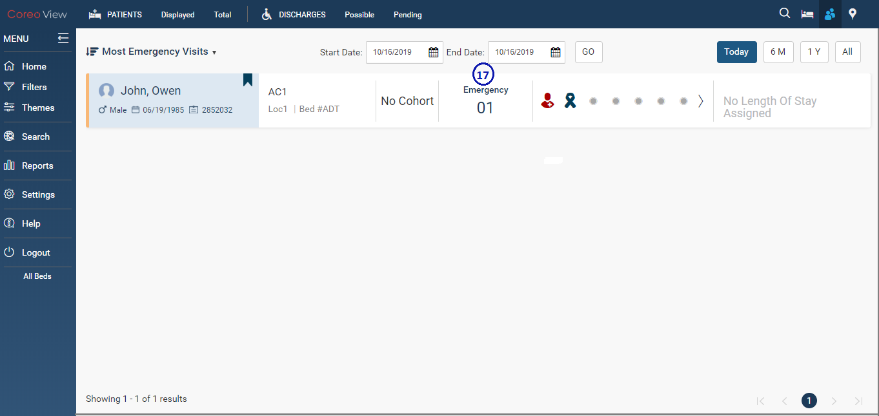

1. Prioritized View – Most Emergency Visits

Refer to the following table for the user interface element details:

| Serial Number | Element name | Description |
| --- | --- | --- |
| 17 | **Emergency** | Displays the number of emergency visits for the patient. |

1. Prioritized View – Patient Emergency details

Screen Layout for Highest Risk Scores

Refer to the figure for the prioritized view layout of the patients with highest risk scores:

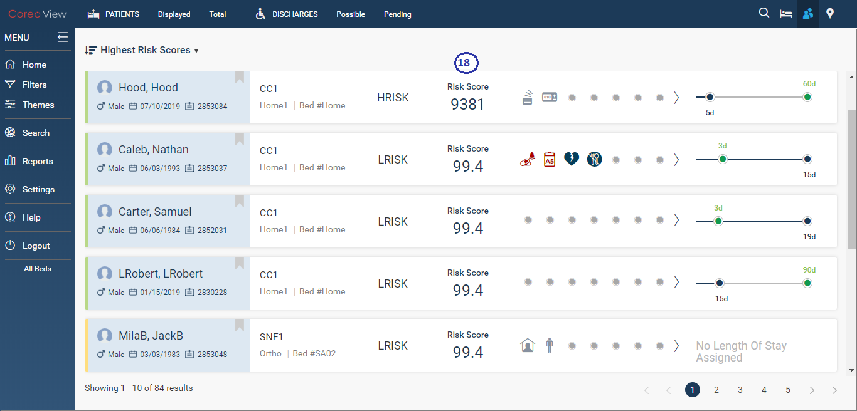

1. Prioritized View – Highest Risk Scores

Refer to the following table for the user interface element details:

| Serial Number | Element name | Description |
| --- | --- | --- |
| 18 | **Risk score** indicator | The high risk, medium risk, or low risk score of the patient matching the cohort. |

1. Prioritized View – Risk Score Indicator

Screen Layout for Most Recently Admitted – Inpatient

Refer to the figure for the prioritized view layout of the most recently admitted inpatients:

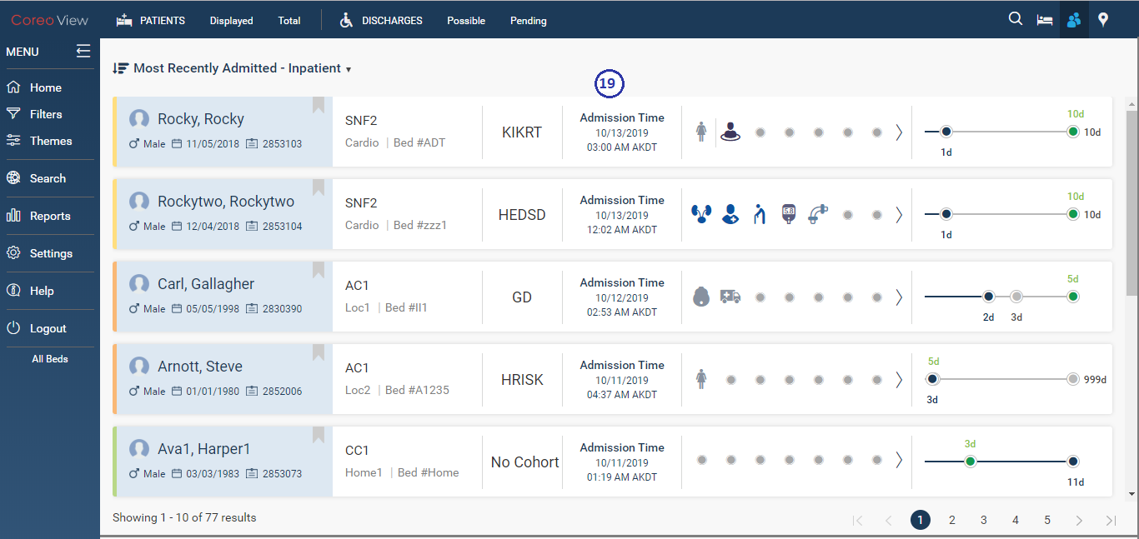

1. Prioritized View – Most Recently Admitted - Inpatient

Refer to the following table for the user interface element details:

| Serial Number | Element name | Description |
| --- | --- | --- |
| 19 | **Admission Time** | The time at which the patient was admitted to the facility. |

1. Prioritized View – Admission Details

Screen Layout for Most Recently Discharged – Inpatient

Refer to the figure for the prioritized view layout of the most recently discharged inpatients:

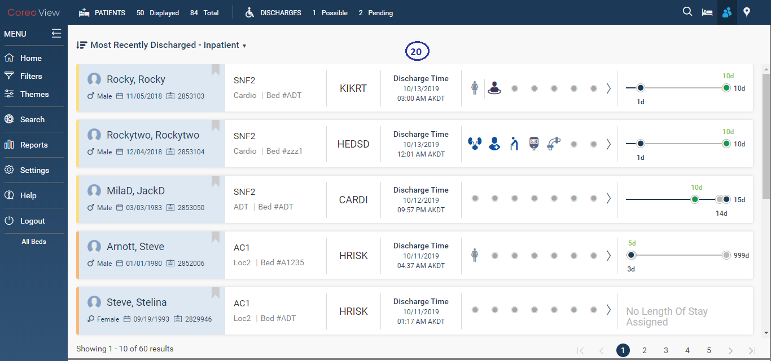

1. Prioritized View – Most Recently Dischaged - Inpatient

Refer to the following table for the user interface element details:

|  |  |  |
| --- | --- | --- |
| Serial Number | Element name | Description |
| 20 | **Discharge Time** | The time at which the patient was discharged from the facility. |

1. Prioritized View – Discharge Time Details

Screen Layout for Longest Length of Stay

Refer to the figure for the prioritized view layout of the longest length of stay of the patients:

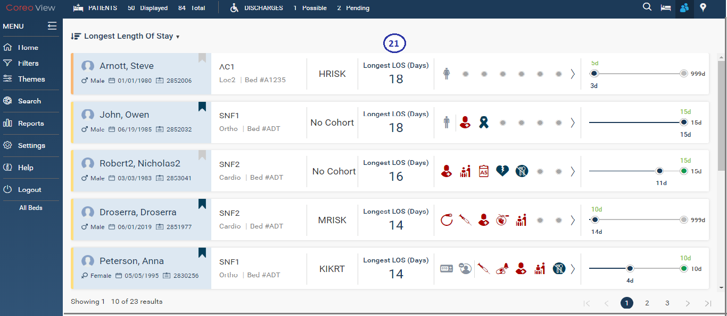

1. Prioritized View – Longest Length of Stay

Refer to the following table for the user interface element details:

|  |  |  |
| --- | --- | --- |
| Serial Number | Element name | Description |
| 21 | Longest LOS (Days) | The standard length of stay of the patient in days for that level of care, the different levels of care include AC, PAC, and CC. |

1. Prioritized View – Longest Length of Stay Details

## Geo-Map View Layout

Use the **geo-map view** feature to display the patient details associated with the location on a geographical map.

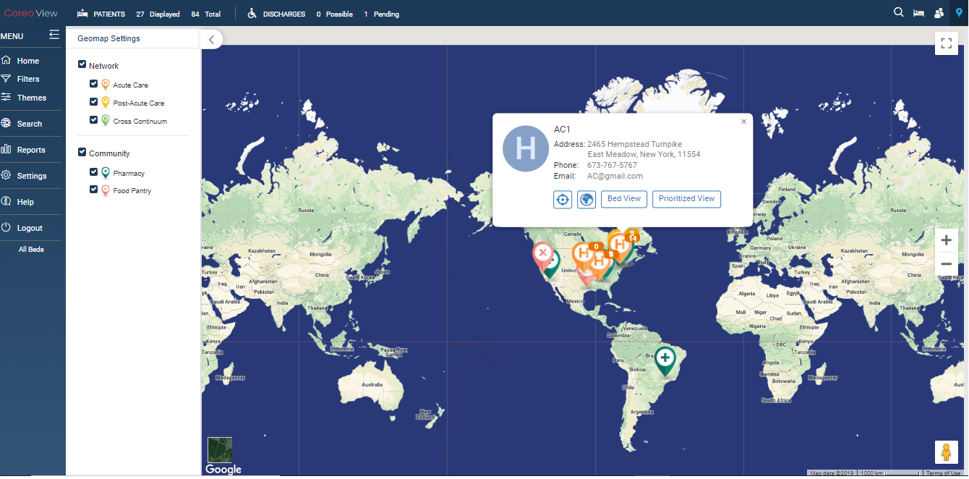

1. Geomap View Layout

Refer to the following table for details on the UI elements of the Geomap view:

| Icon | Element name | Description |
| --- | --- | --- |
|  | **Geomap Settings** arrow | Select the arrow to expand the Geomap settings menu. |
|  | **Network** check box | Select the **Network** check box to view the geographical location of all the three groups and the associated locations. |
|  | **Acute Care** check box | Select the **Acute Care** check box to view the number of patients associated with the AC location on a geographical map. |
|  | **Post-Acute Care** check box | Select the **Post-Acute** **Care** check box to view the number of patients associated with each SNF location on a geographical map. |
|  | **Cross Continuum** check box | Select the **Cross Continuum** check box to view the geographical location of a patient in the CC network. |
|  | **Community** check box | Select the **Community** check box to select the **Pharmacy** check box and the **Food** **Pantry** check box. |
|  | **Pharmacy** check box | Select the **Pharmacy** check box to view the nearby pharmacy locations in the neighborhood. |
|  | **Food Pantry** check box | Select the **Food Pantry** check box to view the nearby food pantry locations in the neighborhood. |
|  | AC Group marker | Displays the geographical location of the AC group.  The number on the marker displays the total number patients in that specific group. |
|  | PAC Group marker | Displays the geographical location of the PAC group.  The number on the marker displays the total number of patients in a location of the PAC group. |
|  | CC Group marker | Displays the geographical location of a patient of a CC group. |
|  | Information box | Displays the address details of a group.  The information in this box changes based on the level of the group; AC, PAC, or CC.  Refer to the GEOMAPPING View Features module for more details on how to read the information box. |
|  | Toggle Full Screen icon | Use this button to view the geomap layout in full screen mode. Toggle this button to change to the window screen mode. |
|  | Magnification icon | Zoom in (+) to increase the size of the geomap view layout or zoom out (-) to decrease the size of the geomap view layout |
|  | Peg man icon | Drag the peg man to the desired location in the geomap to zoom into the street view imagery. |

1. UI Elements for the Geomap View

# Using Filters and Themes

The Coreo View users can apply filter criteria to the patient list based on hospital groups, locations, patient cohorts, insurance providers, patient disposition status, patient attributes and activities, bed attributes and risk factors. Only the related patient records are listed and the other records are cleared from the view.

Coreo View allows its users to create and save new themes based upon the filter criteria such as hospital groups, locations, patient cohorts, insurance providers, patient information and so on.

A theme customizes the look of the Coreo View screen and its layout based on the filter criteria.

## Filters

Apply filters to display patient records based on the filter criteria. Only those patient records that meet the filter criteria are displayed.

Follow these steps to apply one or more filter criteria to display specific patient records:

1. In the left pane of the **Coreo View** home page, select the **Filters** menu to open the **Filter** window.

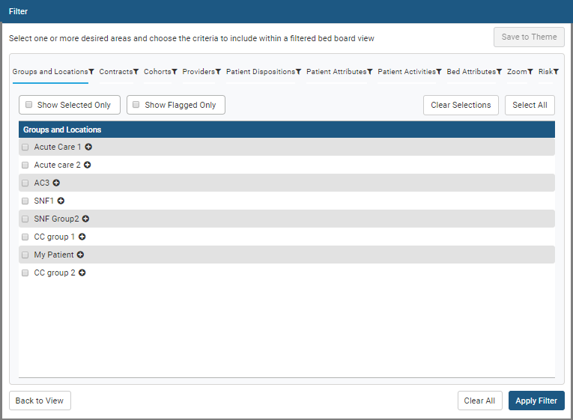

1. Filter Window
2. Select one or more filter criteria from the following which are displayed as tabs across the **Filter** window:

* **Groups and Locations**
* **Contracts**
* **Cohorts**
* **Providers**
* **Patient Dispositions**
* **Patient Attributes**
* **Patient Activities**
* **Bed Attributes**
* **Zoom**
* **Risk**

1. Select one or more options under each filter criterion to limit the patient list display.

|  |  |
| --- | --- |
|  | The options available under each filter criterion is based on the user’s role and access permission granted to them by the Coreo View administrator. |

1. Select the **Groups and Locations** criterion to limit the patient list based on specific groups and locations.

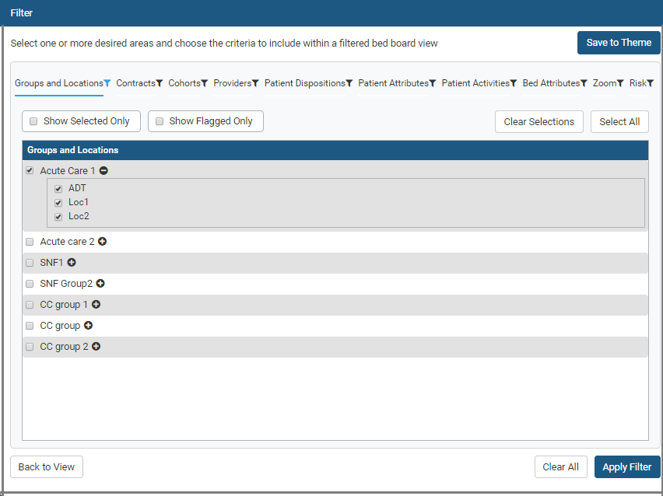

1. Filter Window – Groups and Locations options selected

The user can view only those groups and locations for which the they have access permission.

1. Select the location names for which the patient list must be displayed.

The filter icon next to the criterion name turns blue when one or more options under that filter is selected.

1. Similarly, select one or more of other criteria based on which the patient list must be displayed.
2. Select the **Show Selected Only** check box to view only those options that are selected for that filter criterion.
3. Select the **Clear Selections** button to clear all the options that are selected for the criteria.
4. Select the **Select All** button to select all the available options for a filter criterion.
5. Select the **Save to Theme** button if you want to save the filter criteria as a new theme. A theme is a visual representation of locations, beds and patients. The **Save** **Themes** window opens.

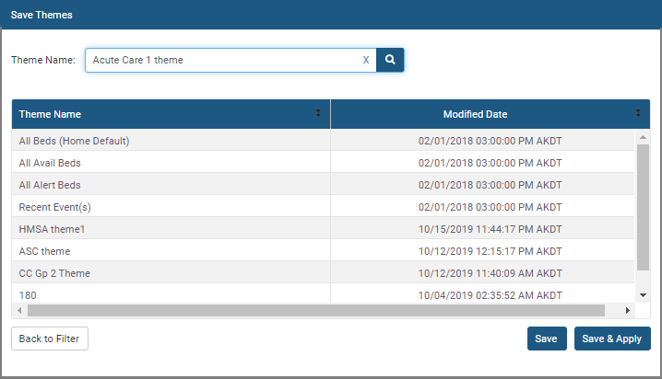

1. Save Themes Window
2. Enter the name for the saved filter criteria in the **Theme Name** box.
3. Select **Save** to save the theme and then select **Back to Filter** to go back to the **Filter** window without applying the theme.
4. Select the **Apply filter** button in the **Filter** window to apply the filter results directly in the bed view without saving the filter criteria as a theme.

Or,

1. Select **Save & Apply** in the **Save Themes window** to apply the theme with immediate effect. You can view the applied theme on the bed view home page.

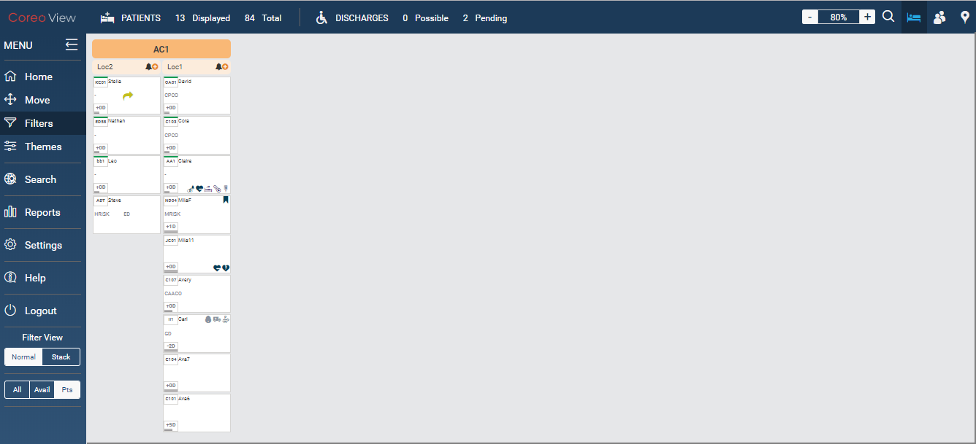

1. Filter Criteria saved and applied as a Theme in the Bed View

## Themes

A theme is a visual representation of locations, beds and patients. The user can apply a theme, set a theme as the home default theme and can edit a theme.

Apply a theme

Follow these steps to apply a theme to the Coreo View home page for the three views, the bed view, the prioritized view and the geomap view:

1. In the left pane of the **Coreo View** home page, select the **Themes** menu to open the **View Themes** window.

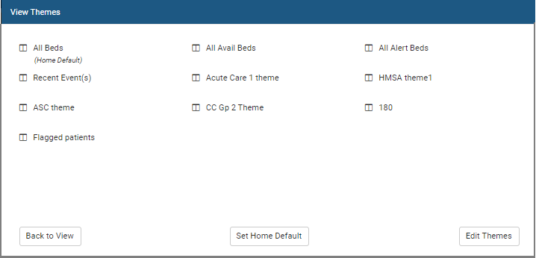

1. View Themes Window
2. Select a theme and the theme applies across all three views, the bed view, the prioritized view and the geo-map view.

Set a theme as the home default theme

A home default theme is the layout that the user sees on the Coreo View home page across all three views, the bed view, the prioritized view and the geo-map view each time the user logs into Coreo View.

1. Select the **Set Home Default** button in the **View Themes** window.
2. Select a theme that you want to set as the home default theme. The **(Home Default)** label displays below the selected theme.
3. Select **Back to View** to view the applied changes to the three view layouts.

Edit a theme

The user can delete a theme that is not used any more. **All Beds**, **All Avail Beds**, **All Alert Beds**, and **Recent Event(s)** themes are the system defined themes and the user cannot be edit them.

1. Select the **Edit Themes** button in the **View Themes** window. The **Edit** **Themes** window opens.

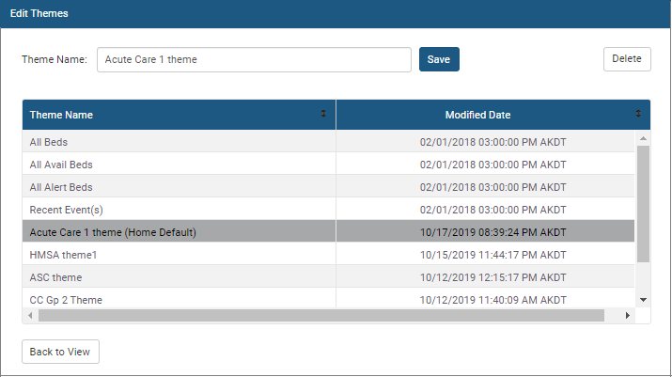

1. Edit Themes Window
2. Enter the name of the theme to be deleted in the **Theme Name** box, or select the theme directly in the grid.
3. Select **Delete** to delete the theme. A confirmation message box is displayed.

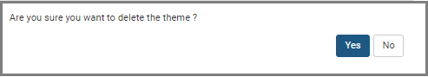

1. Delete Confirmation Message Box
2. Select **Yes** to confirm the deletion of the theme.
3. If a user-defined home default theme is deleted, the system-defined home default theme, **All Beds**, is applied automatically.
4. To rename a theme, enter the theme name to be renamed in the **Theme Name** box, enter the new name and then select the **Save** button.
5. Click the **Back to View** button to exit the **Edit Themes** window.

## Normal view and Stacked view

In the normal view and the stacked view of the bed view layout, the beds per column are categorized based on the three groups and their locations. However, the placement of the bed cells is different in both the views.

Normal view is the default view. It displays the empty bed cells and the occupied bed cells in each column placed adjacent to each other.

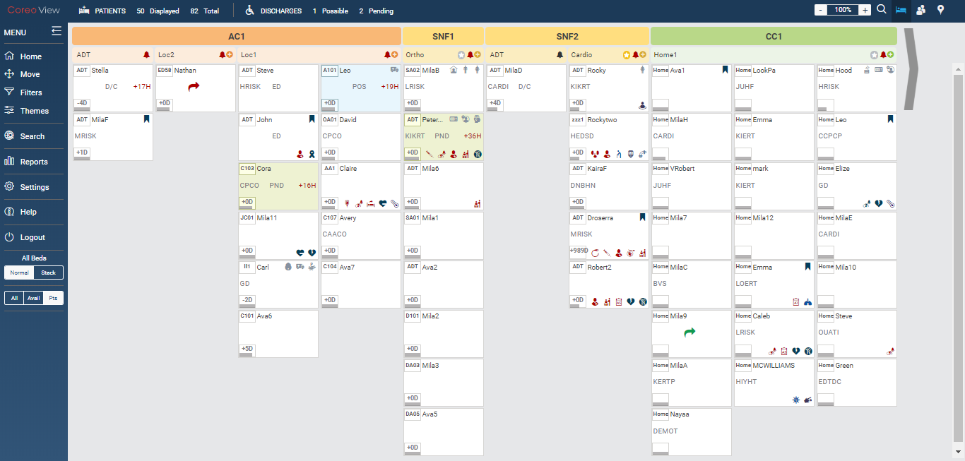

1. Bed View – Normal View Mode

The stacked view displays the empty bed cells and the occupied bed cells in each column placed one below the other. The beds per column are categorized based on the three groups and their locations.

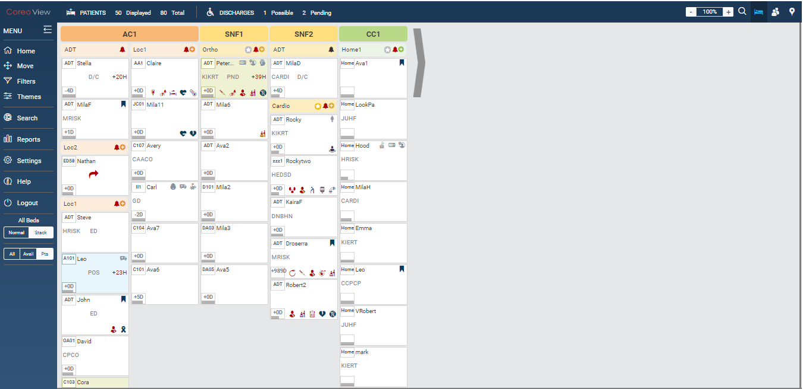

1. Bed View - Stacked View Mode

## All, Available and Patient Viewing Modes

The All view mode displays the empty bed cells, the bed cells occupied with patients and the empty locations.

The Available view mode displays the empty bed cells that are available to assign to the patients and the occupied beds.

The Patients view mode displays bed cells that are occupied with patients. This is the default bed view mode.

Follow this step to display the bed information and patient information with respect to the groups and locations in the Available view mode:

1. In the left pane of the Coreo View home page, select the **Avail** button, which is one of the buttons in the tristate button.

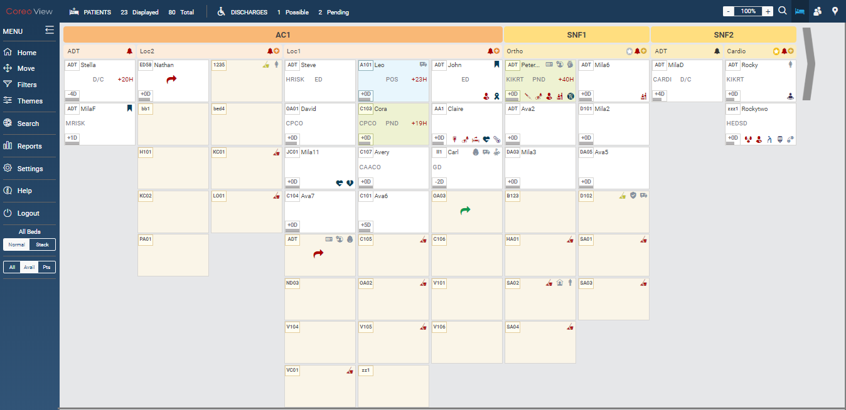

1. Available View Mode for the Bed View Layout

Follow this step to display the bed information and patient information with respect to the groups and locations in the Patients view mode:

1. In the left pane of the Coreo View home page, select the **Pts** button, which is one of the buttons in the tristate button.

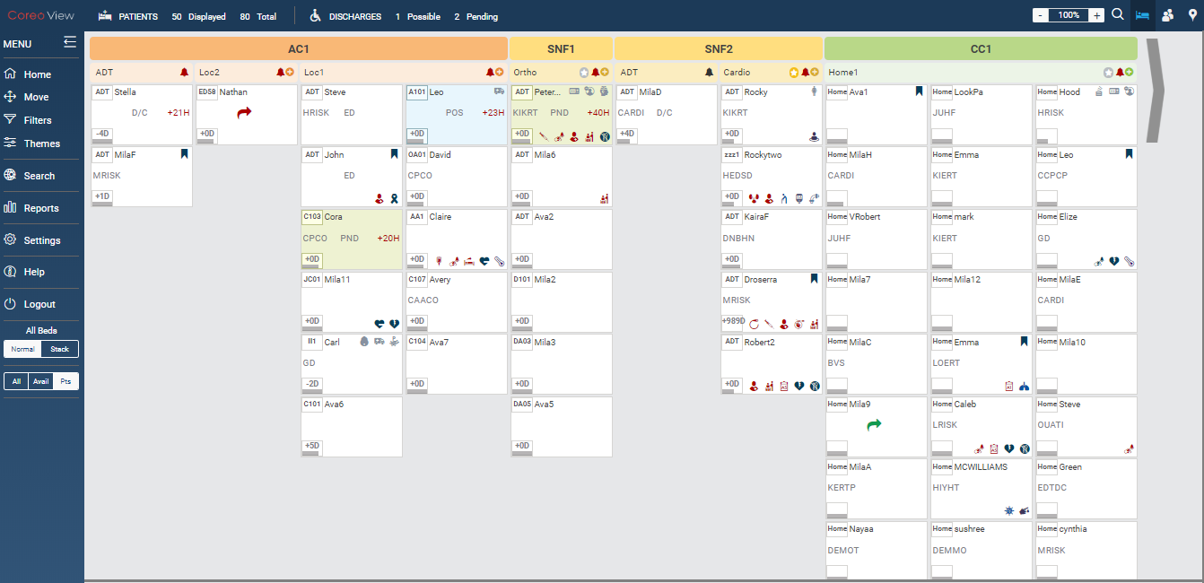

1. Patients View Mode for the Bed View Layout

You can use the three viewing modes in combination with the Normal view mode and the Stack view mode.

Refer to the following table to view the various combinations of the viewing modes for the bed view layout:

|  |  |  |  |
| --- | --- | --- | --- |
| Viewing modes | All | Avail | Pts |
| Normal | Yes | Yes | Yes |
| Stack | Yes | Yes | Yes |

1. Combination of viewing modes

# Bed view features

## Create bed

## Assign patient

## Move patients based on ADT events

Request move

Quick move

Move within a location

Moving across locations

# Prioritized view features

## Card view

## Sorting

## Application of the date filters

## Filters and themes

# Geo-mapping view features

## Geo-map view

## Toggle views

## Search functionality

## Geo-map view plotting

## Display settings

## Drill down view

## Pop up views

Acute Care

Post-Acute Care

Community resources

# Switching navigation between views

## Toggle views

# Patient summary

Layout and description of different tabs

View patient summary

Patient summary based on bed information

Patient summary based on length of stay (LOS)

Patient summary based on patient information

Length of stay (LOS)

Activities & attributes

Patient disposition

Bed attributes

Coreo face sheet

# Search feature

Global search

Coreo summary

Flagged summary

Bed summary

Displayed search (Bed view search?)

Flagging patient records

Flag a patient record

Patient summary (Give reference to topic 8 above)

Global search

Prioritized view

Geo-map view

Bed view

Applying Filters and saving theme for flagged patients

Flagged Summary Pop Up Elaboration

General reports

Exhibit B: Coreo View Administrative Function



# Coreo View Administrator Tasks

The okta Single Sign-On system administrator has the super user privileges and creates the Coreo View administrator role. okta provides a single secure home page to use the Coreo View application.

The Coreo View administrator manages the users and all the related administrative functions, which include the following:

* Manages the regular users of the Coreo View application.
* Assigns roles and permissions for the regular users from the user groups.

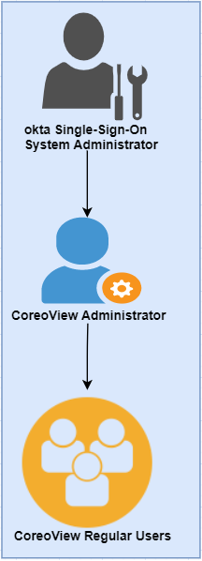

1. Administrator Role Hirearchy

## Navvis account activation for the Coreo View administrator user

The okta system administrator will register a user in okta and assigns the administrative privilege and access to the Coreo View application. The Coreo View administrator user manages the Coreo View regular users.

The okta system administrator sends an email notification to the Coreo View administrator user to initiate the account activation process.

|  |  |
| --- | --- |
| Note icon.png | okta sytem administrator can create multiple Navvis administrator accounts for the Coreo View application. However, the Coreo View administrator can only assign the administrator role to another user in Coreo view. |

Follow these steps to activate the Okta account:

1. Open the email link sent to your email inbox by the Okta administrator.



1. Email Notification

2. Select the ActivateAccLinkGreenBox.png link. The **Create your Navvis account** screen opens.

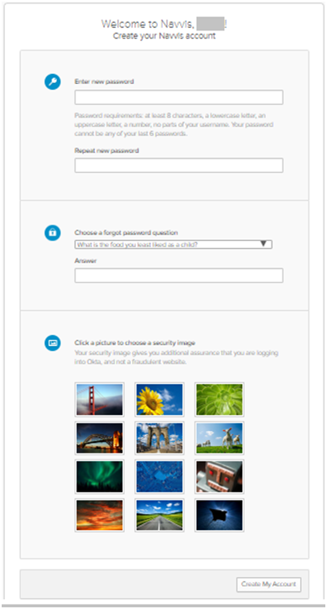

1. Create Your Navvis Account Screen
2. Enter the new password in **Enter new password**. The password must be at least 8 characters long and a maximum of 25 characters.

The password must be a combination of these following characters:

| Description | Characters |
| --- | --- |
| Upper case characters | A – Z |
| Lower case characters | a – z |
| Digits | 0 – 9 |
| Special characters | ~ ! @ # $ % ^ & * _ - + = ` | \ () {} [] : ; " ' < > , . ? / |

1. System Accepted Password Characters
2. Reenter the password in the **Repeat new password** box.

The user must add a security question to reset a new password in the event of the user forgetting the password during the future use.

1. Under **Choose a forgot password** question, select the arrow to view the questions.

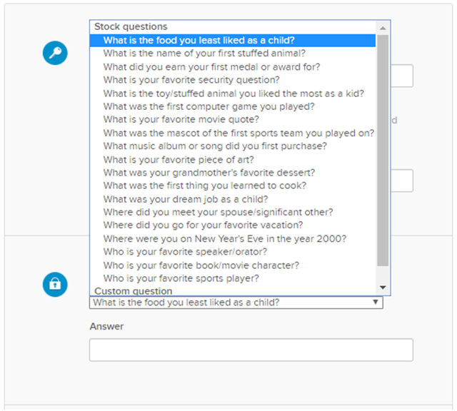

1. Choose A Forgot Password Question
2. Choose a security question from the list.
3. In the **Answer** box, enter the answer. You must remember this answer because it is used at a later date to reset a forgotten or expired password.
4. Choose a picture as a security image in the **Create your Navvis account** screen and then select **Create My Account**.

|  |  |
| --- | --- |
| Note icon.png | The security image displays in the NAVVIS Sign In screen when the user logs in. |

1. The **Navvis** landing screen opens.

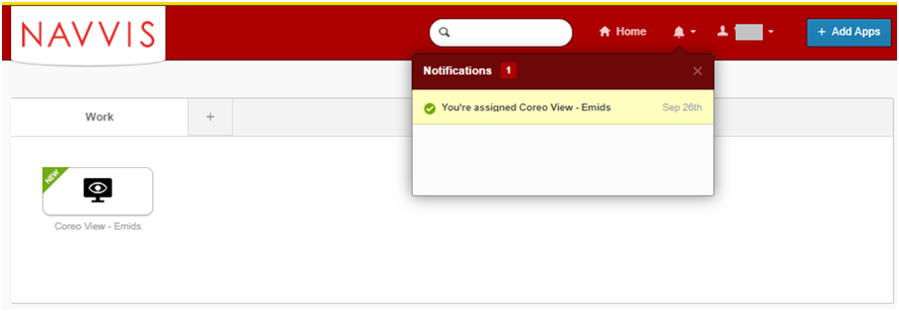

1. NAVVIS Landing Screen
2. Select the **Coreo View - Emids** icon on the landing screen.
3. The **NAVVIS Sign in** screen opens.

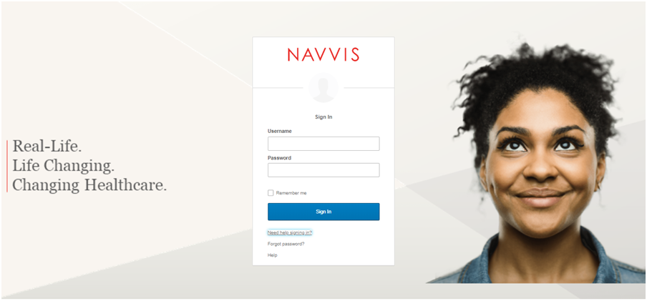

1. NAVVIS Sign In Screen
2. Enter the user ID in the **Username** box on the.
3. Enter the password in the **Password** box. The password must be at least 8 characters long and a maximum of 25 characters.
4. Select **Sign In**.
5. The EULA screen displays for a first-time user of Coreo View. A first-time user of Coreo View is required to accept the EULA (End User License and Business Associate Agreement) before accessing the Coreo View application.

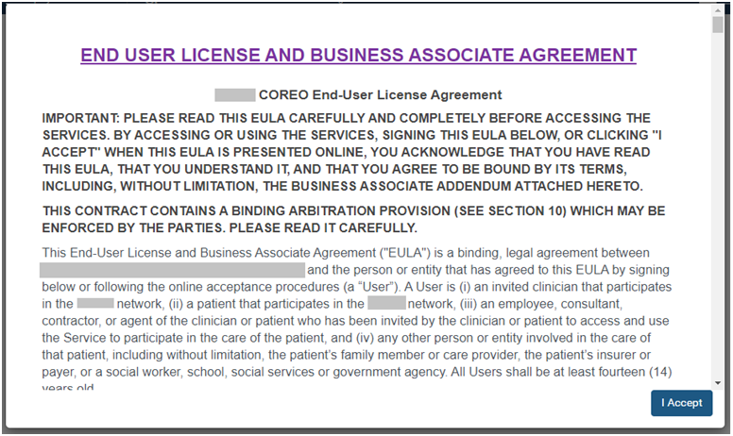

1. EULA PAGE
2. Read the terms and conditions and select the **I Accept** button. Your Navvis account is activated successfully and the NAVVIS home page opens.

## Manage locked Navvis administrator account

The Navvis account locks for the following reasons:

* The user exceeds five failed login attempts within 24 hours. The login attempts fail when the user enters an incorrect password.

To unlock the Navvis account immediately after the five failed login attempts, contact the okta system administrator.

|  |  |
| --- | --- |
| Note icon.png | The locked account resets after 24 hours and the user can log in to the account after 24 hours. |

* The okta system administrator can lock the Navvis account as per the company lock account policy.

## Reset a forgotten or expired administrator password

The okta Single Sign-On password policy specifies that the password expires after 60 days, and the user must reset the password periodically.

Also, if the user forgets the password, Coreo View gives the option to reset the password.

Follow these steps to reset the password:

1. Go to www.navvis.oktapreview.com to open the **Navvis Sign in** screen.

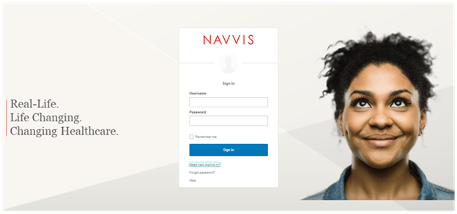

1. NAVVIS Sign In Screen - Forgot password? Option
2. Select the **Need help signing in?** drop-down list.
3. Select the **Forgot password?** option to open the **Reset Password** screen.

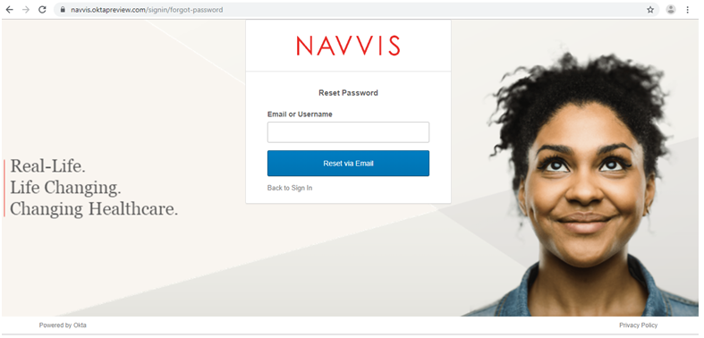

1. Reset Password Screen
2. Enter the e-mail or the user name in the **Email or Username** box.
3. Select **Reset via E-mail**. The user can reset the password using the verification link sent to the user’s email address.
4. Reset the password with the following considerations:

* The new password cannot be among the previous six passwords.
* The password expires after 60 days and the user must reset the password periodically.
* The user will be locked out of the application after five failed login attempts. The login attempts fail when the user enters an incorrect password. Contact the okta administrator to reset the password.

On the successful resetting of the password, the new password is reset for the Navvis account.

Settings to manage Coreo View regular users

The user management settings for Coreo View is set up by creating hospital groups, locations, users, user roles, user permissions to use the features, user roasters and patient cohorts.

## Settings page layout

Each screen in Coreo View has the same structure; however, few user interface elements differ depending on the user’s role and permissions.

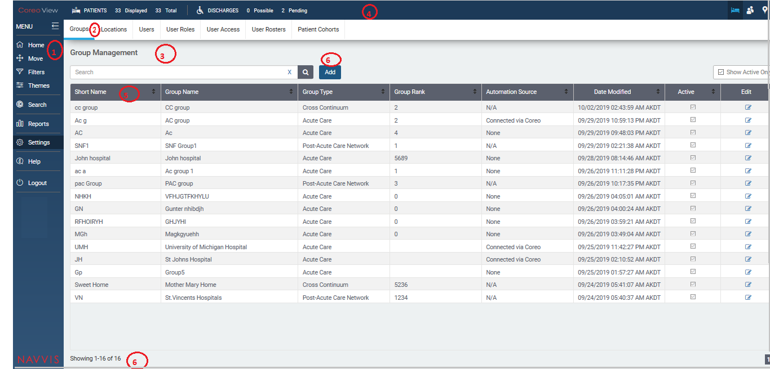

1. Settings Page Layout

## Create groups

The Coreo View application provides the following three groups to categorize patients based on the care facilities that they are provided with.

a) Acute care: Acute care group includes emergency department, intensive care, coronary care, cardiology, neonatal intensive care and so on.

b) Post-Acute Care (PAC) network: Under this care group, patients are cared with skilled nursing facilities, inpatient rehabilitation facilities, long-term acute hospital facilities among others.

c) Cross continuum: Under this care group, patients are cared at their home locations and are served by home-health and outpatient services.

Follow these steps to create a new group in the Coreo View application:

1. Click the Settings menu in the left pane on the Coreo View home page.

2. Click the Add button under the Groups tab. The Add Group tab page opens.

3. Select the type of group from the following options:

• Acute Care

• Post-Acute Care Network

• Cross Continuum

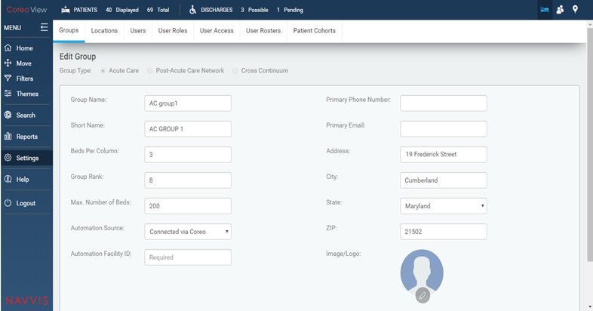

FIGURE 1. GROUPS TAB PAGE

For the Acute Care group type, enter the following details:

4. Enter the acute care group name in the Group Name: field.

5. Enter a short name for the acute care group in the Short Name: field.

6. View the number of beds allotted for each column for this group in the Beds Per Column: field. You can modify this value.

7. View the group rank in the Group Rank: field. The user can modify this value.

8. View the maximum number of beds that is available for this care group in the Max. Number of Beds: field.

9. Select the automation source in the Automation Source: field from the following options:

• Connected via Coreo

• None

10. Enter the primary phone number of the care group in the Primary Phone Number: field.

11. Enter the primary email address of the care group in the Primary Email: field.

12. Enter the address details of the care group in the Address: field.

13. Enter the name of the city in which the care group is located in the City: field.

14. Select the State: arrow to view the states in the U.S region and then select the name of the state in the State: field.

15. Enter the ZIP code of the region that the care group belongs to in the ZIP: field.

16. Select the Save button to changes.

Manage user access

Follow these steps to create user roles on the User Access Management page.

1. On the Coreo View homepage, go to the Settings menu in the left pane.

2. Go to the User Roles tab to open the User Role Management page.

3. Select the Add button to add new user access on the Add User Access page.

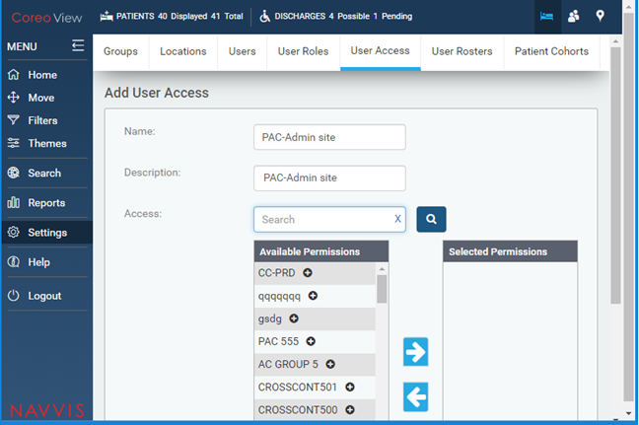

FIGURE 3. ADD USERS ACCESS TAB PAGE

4. Enter the user access name in the Name field.

5. Enter a description for the user access in the Description: field.

6. Enter the group in the Access: search box to grant the permission for and then click the Search button. The groups under the available permissions are displayed based on the search key word.

7. Select the appropriate group under Available permissions to give permissions to the user.

8. Select the right arrow button to move the selected group under Selected Permissions.

9. Click Save to save the user access permissions.

10. View the user access details on the User Access Management page.

## Set up locations

## Manage patient cohorts

## Manage user rosters

## Create user roles

The Coreo View application provides its users with role based permissions to its features.

The roles could include the following:

• Administrator super user

• Administrator

• Hospital administrator

• Hospital nurses / Care giver roles

• Hospital non-clinical roles

• Hospital role types - Care giver roles and Non-clinical roles

• PAC (Post-Acute Care) role types – PAC site admin, Care giver roles and Non-clinical/EVF roles

• CC (Cross Continuum) – CC site admin, Care giver roles and Non-clinical/EVF roles

Follow these steps to create user roles on the User Role Management page.

1. On the Coreo View homepage, go to the Settings menu in the left pane.

2. Go to the User Roles tab to open the User Role Management page.

3. Select the Add button.

4. Enter the name of the user role in the Name: field.

5. Enter a description for the user role in the Description: field.

6. Enter the feature in the Access Rights: search box to grant the permission for and click the Search button. The features under the available permissions are displayed based on the search key word.

7. Select the appropriate features under Available permissions to give permissions to the user role.

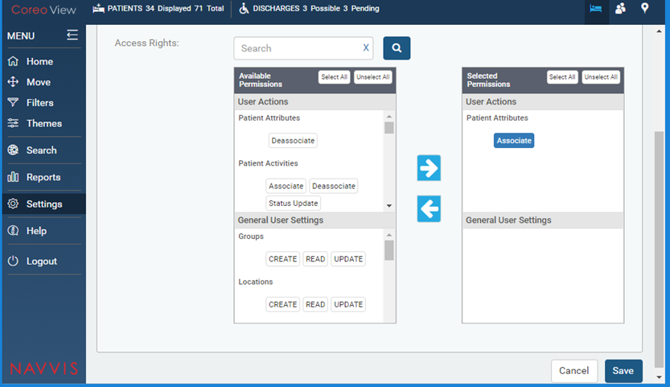

FIGURE 2. AVAILABLE PERMISSIONS FOR USER ROLES

8. Select the Select All button and then click the right arrow button to move the permissions under Selected Permissions.

The available permission for the user role is detailed in the tabular column below:

User Actions

Features Permissions

Patient Attributes Associate, Deassociate

Patient Activities Associate, Deassociate, Status Update

Bed Attributes Associate, Deassociate

Bed Cleaning Cleaning Required, Cleaning Complete

Move/Assign Patient Request Move, Assign Patient, Accept Move, Reject Move, Cancel Move, Quick Move

Providers & LOS Length of Stay

Patient Disposition Observation, Admitted, Discharge Possible, Discharge Pending, Discharge Complete, Emergency

Patients READ, UPDATE, DELETE

Audit Trail Reports READ, Download

Reports READ, Download

Automation Logs READ, UPDATE

Move/Transfer Patient Transfer Patient

Cohort Management Bulk Assign

Notifications Roster Updates

General User Settings

Features Permissions

Groups CREATE, READ, UPDATE

Locations CREATE, READ, UPDATE

Beds CREATE, READ, UPDATE, DELETE

Users CREATE, READ, UPDATE, DELETE

User Roles CREATE, READ, UPDATE

User Access CREATE, READ, UPDATE

Rosters CREATE, READ, UPDATE

Cohorts READ, UPDATE

Table X-X: Available permissions for the user roles

9. Click Save to save the user role permissions.

10. View the newly created user role on the User Role Management page.

## Create users

# Automation Events

## Discharging ED patients automatically and moving to CC after a configurable time

## Moving the low risk patient automatically from ADT to cc after a configurable time

## SIGNAL R –keeping the screen updated automatically

Administrative Reports

## Automation reports

## Automation action

Appendices

Credits

[www.bloomberg.com/profile/company/3553499Z:US](http://www.bloomberg.com/profile/company/3553499Z:US)

[www.navvishealthcare.com/](http://www.navvishealthcare.com/)

[www.linkedin.com/company/navvishealthcare](http://www.linkedin.com/company/navvishealthcare)

[www.pitchbook.com/profiles/company/88126-75](http://www.pitchbook.com/profiles/company/88126-75)

[www.crunchbase.com/organization/navvis-company](http://www.crunchbase.com/organization/navvis-company)

[www.healthcareitnews.com/blog/defining-population-health](http://www.healthcareitnews.com/blog/defining-population-health)

www.shareicon.net

Glossary

[Glossary term – Description]

[Glossary term – Description]

[Glossary term – Description]

[Glossary term – Description]

[Glossary term – Description]

……………………..

Index

[Depending on the size or complexity of the final document, insert an index to assist the user in locating specific information. Index entries correspond to tags or categories, and are useful in navigating long books.]

[Index term – *page number*]

[Index term – *page number*]

[Index term – *page number*]

[Index term – *page number*]

[Index term – *page number*]